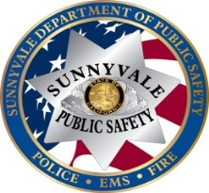**SUNNYVALE DEPARTMENT OF PUBLIC SAFETY**

**_____________________________________________________**

Sunnyvale Department of Public Safety wants to remind everyone of simple safety considerations that will help ensure that we all have a safe school year. Traffic violations around school zones increase dramatically during drop off and pick up times. By simply dropping off your child a block or two away from the school, you will alleviate a great deal of the school zone traffic thus reducing the likelihood of a collision. Considering alternative routes that result in right hand turns into the parking lots and drop-off zones instead of left turns will also improve traffic flow. In addition, there are numerous Sunnyvale crossing guards in the surrounding neighborhood to ensure your children cross safely. Please discuss traffic safety with your children to ensure they know the laws that relate to bicycling, walking, or skateboarding.

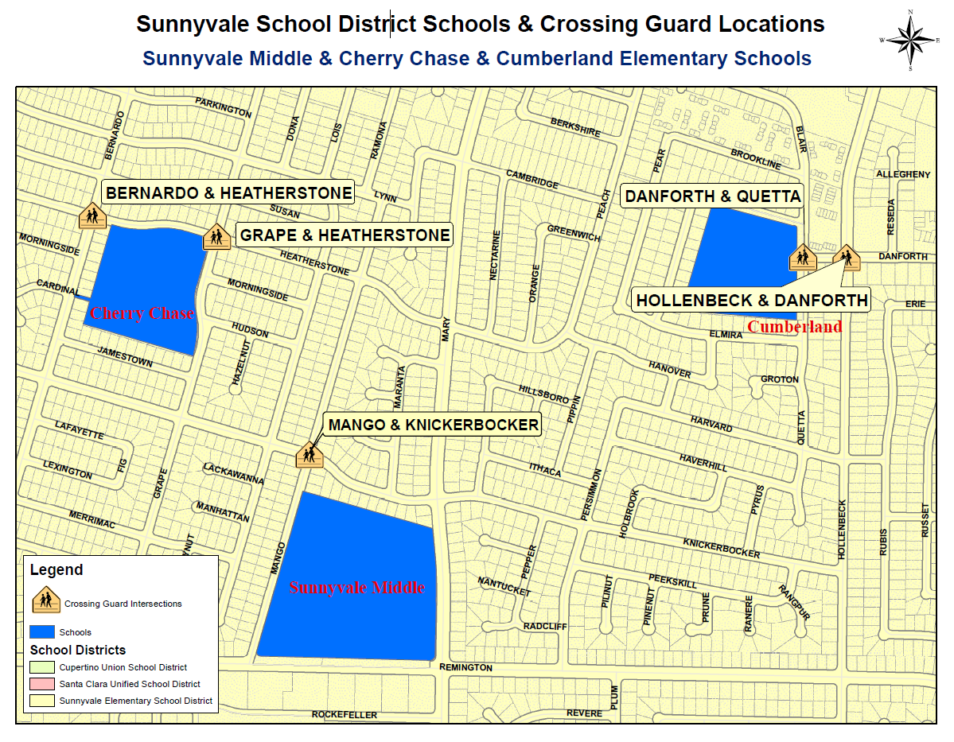

**COMMON TRAFFIC VIOLATIONS NEAR SCHOOLS**

**Bicycle Violations:**

•Bicyclists must obey the same rules of the road as vehicles

•Always ride on the right hand side of the road

•Helmet required for minors (under 18 years old) on bike, scooter or skateboard

•No passengers on bicycle unless separate seat is attached

**Pedestrian Violations:**

•Always use crosswalks

•Obey the crossing guards

**Vehicle Violations:**

• No parking in red zones (even if driver is waiting in vehicle)

• No parking in bus loading zones (even if driver is waiting in vehicle)

• No parking in crosswalks (even if driver is waiting in vehicle)

• White curbs are intended for loading and unloading only

• Double parking

• Stop sign violations and speeding (any speed unsafe for conditions)

• Illegal left hand turn out of the school parking lot where signs are posted

• Illegal U-turns (within 200’ of any approaching vehicle, bicycle or pedestrian)

• Always wear your seat belt!